**/*Este query me devuelve los países en los que se venden los productos y**

**la suma de ventas históricas en cada pais*/**

select

s.[Group] as Continente,

r.[Name] as Pais,

s.CountryRegionCode,

SUM(SalesYTD) as HistoricoVentas,

SUM(s.SalesLastYear) as VentasAñoPasado

from Sales.SalesTerritory as s

join Person.CountryRegion r

on s.CountryRegionCode = r.CountryRegionCode

group by s.[Group],r.[Name], s.CountryRegionCode

order by HistoricoVentas desc

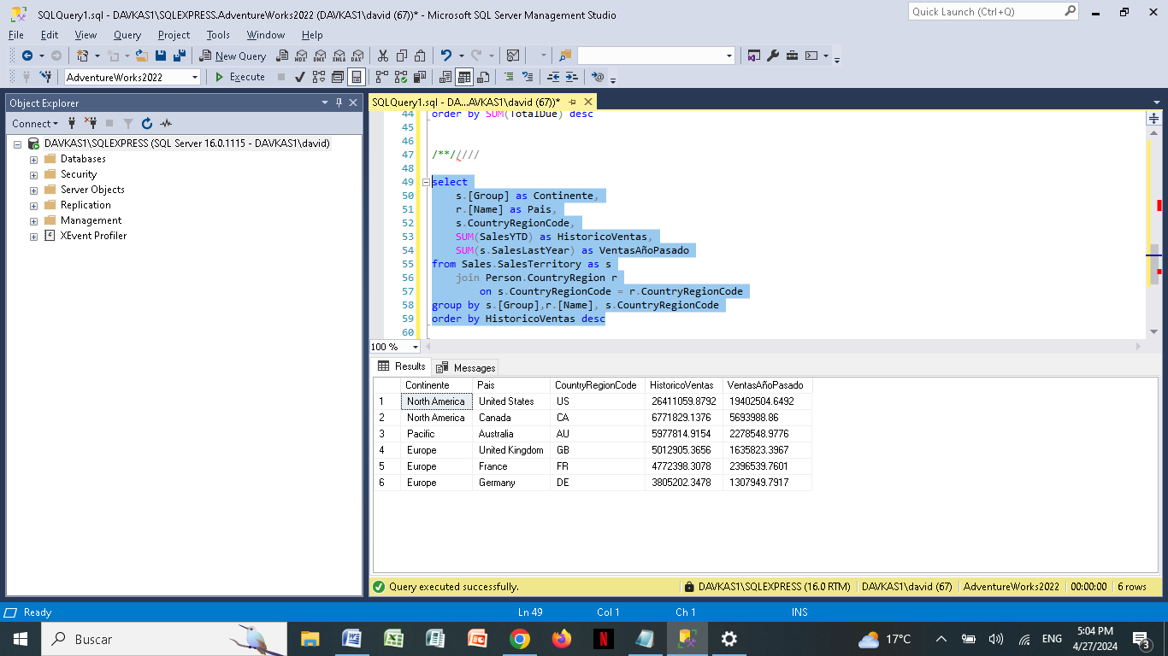

**/*Este query me devulve los paises o region del pais en caso de USA en los que se venden los productos y la suma de ventas historicas en cada pais*/**

select

s.[Group] as Continente,

r.[Name] as Pais,

s.CountryRegionCode,

SUM(SalesYTD) as HistoricoVentas,

SUM(s.SalesLastYear) as VentasAñoPasado

from Sales.SalesTerritory as s

join Person.CountryRegion r

on s.CountryRegionCode = r.CountryRegionCode

group by s.[Group],r.[Name], s.CountryRegionCode

order by HistoricoVentas desc

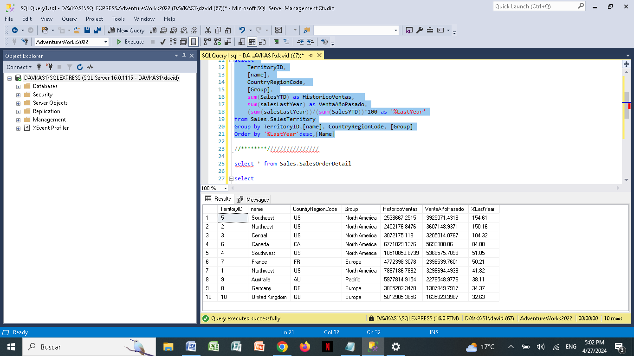

**/*Este query saca el historico de ventas por paises.**

**para comparar los valores de los historicos*/**

select

--h.SalesOrderID,

--h.OrderDate,

--h.CustomerID,

--h.SalesPersonID,

c.[Name] as Pais,

SUM(TotalDue) as SumSubTotal

from Sales.SalesOrderHeader as h

join Sales.SalesTerritory as s

on h.TerritoryID = s.TerritoryID

join Person.CountryRegion as c

on s.CountryRegionCode = c.CountryRegionCode

group by c.[Name]

order by SUM(TotalDue) desc

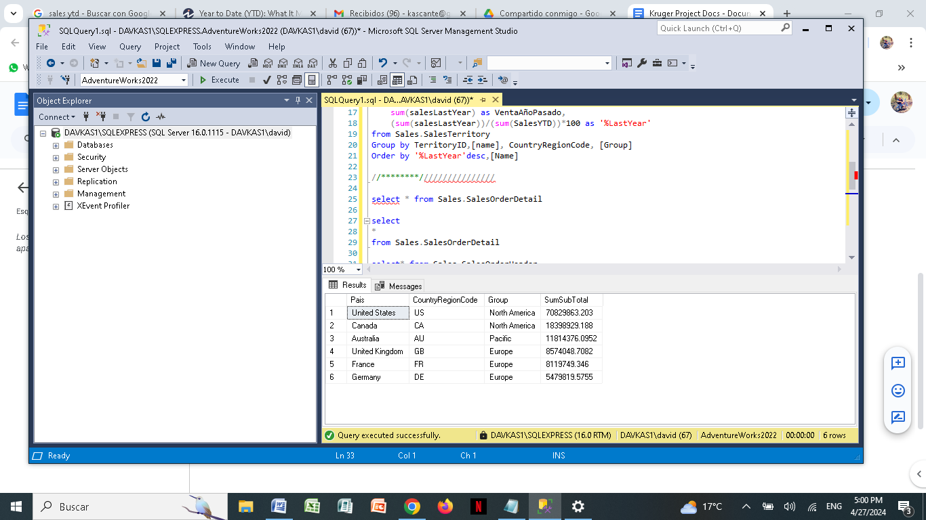

**/*En este Query comprueba el histórico de ventas que obtuve de la SalesOrderHeader con**

**el histórico de ventas que obtuve de los territorios*/**

select

s.[Group] as Continente,

r.[Name] as Pais,

s.CountryRegionCode,

t1.SumSubTotal as HistoricVentasHeader,

SUM(SalesYTD) as HistoricoVentas,

(t1.SumSubTotal-SUM(SalesYTD)) as Diff,

SUM(s.SalesLastYear) as VentasAñoPasado

from Sales.SalesTerritory as s

join Person.CountryRegion r

on s.CountryRegionCode = r.CountryRegionCode

join (select

c.[Name] as Pais,

SUM(TotalDue) as SumSubTotal

from Sales.SalesOrderHeader as h

join Sales.SalesTerritory as s

on h.TerritoryID = s.TerritoryID

join Person.CountryRegion as c

on s.CountryRegionCode = c.CountryRegionCode

group by c.[Name]) as t1

on r.[Name] = t1.Pais

group by s.[Group],r.[Name], s.CountryRegionCode, t1.SumSubTotal

order by HistoricoVentas desc

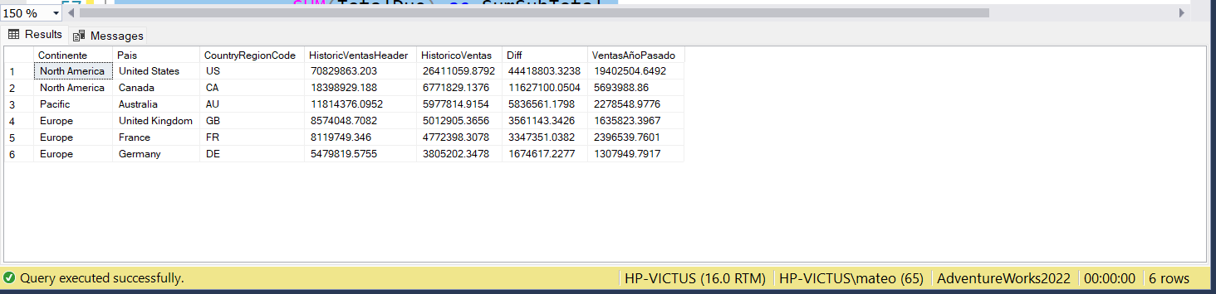

**/* Este query saca los ingresos totales por cada mes del año /\***

SELECT

YEAR(OrderDate) AS Año,

MONTH(OrderDate) AS Mes,

SUM(UnitPrice * OrderQty) AS IngresosTotales

FROM

Sales.SalesOrderHeader AS soh

INNER JOIN

Sales.SalesOrderDetail AS sod ON soh.SalesOrderID = sod.SalesOrderID

GROUP BY

YEAR(OrderDate),

MONTH(OrderDate)

ORDER BY

Año, Mes;

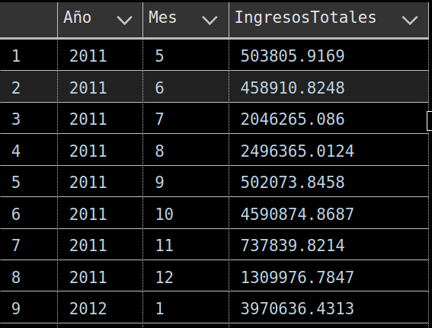

**/*En este Query saca la información de ventas por 1 año detallado por cada mes*/**

**NOTA: se busca que se pueda sacar este query y replicarlo de forma horizontal para que en a vista nos permita visualizar los siguientes años en columnas separadas/**

SELECT

MONTH(soh.OrderDate) AS Mes,

SUM(UnitPrice * OrderQty) AS Ingresos2012

FROM

Sales.SalesOrderHeader AS soh

FULL OUTER JOIN

Sales.SalesOrderDetail AS sod

ON soh.SalesOrderID = sod.SalesOrderID

where year(OrderDate) = 2012

GROUP BY

YEAR(OrderDate),

MONTH(OrderDate)

ORDER BY

Mes

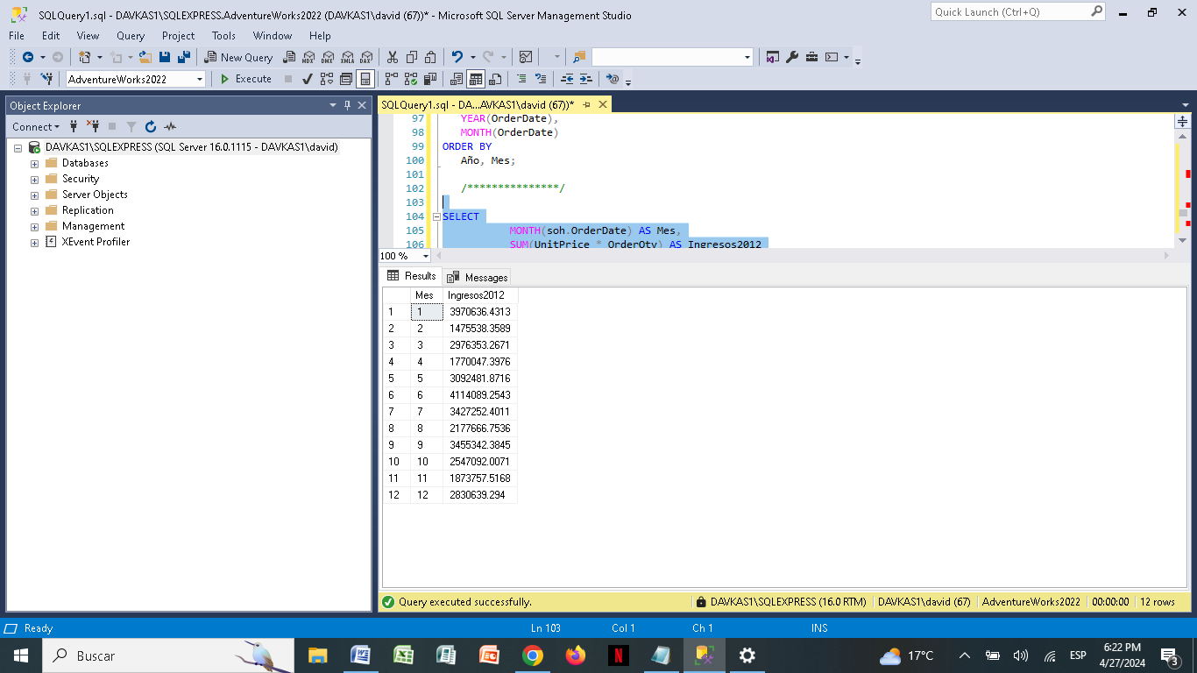

**ESTE QUERY NOS DA LA INFORMACIÓN DE LOS INGRESOS DE CADA MES COMPARADO CON CADA AÑO EN DIFERENTES COLUMNAS.**

SELECT

MONTH(soh.OrderDate) AS Mes,

SUM (case when year(soh.OrderDate) = 2011 then (UnitPrice * OrderQty)end) AS Ingresos2011,

SUM (case when year(soh.OrderDate) = 2012 then (UnitPrice * OrderQty)end) AS Ingresos2012,

SUM (case when year(soh.OrderDate) = 2013 then (UnitPrice * OrderQty)end) AS Ingresos2013,

SUM (case when year(soh.OrderDate) = 2014 then (UnitPrice * OrderQty)end) AS Ingresos2014

FROM

Sales.SalesOrderHeader AS soh

JOIN

Sales.SalesOrderDetail AS sod

ON soh.SalesOrderID = sod.SalesOrderID

GROUP BY

MONTH(OrderDate)

ORDER BY

Mes

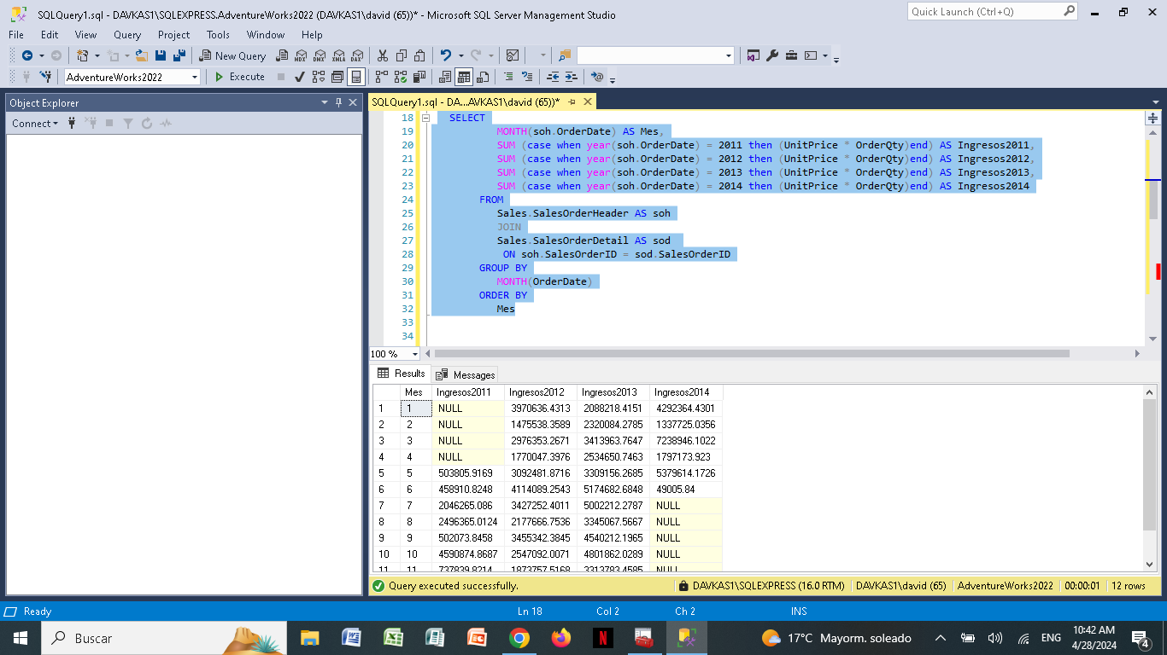

**ESTE QUERY NOS DA LA INFORMACIÓN DE LOS INGRESOS DE CADA MES COMPARADO CON CADA AÑO EN DIFERENTES COLUMNAS, ADICIONALMENTE, NOS DÁ LA COMPARATIVA DEL CRECIMIENTO EN USD CADA AÑO, Y EL PORCENTAJE DE CRECIMIENTO QUE TIENE CADA AÑO.**

select

t1.Mes,

t1.Ingresos2011,

(t1.Ingresos2012 - t1.Ingresos2011) as 'DIFF 2011 al 2012',

((t1.Ingresos2012 / t1.Ingresos2011)-1)*100 as '%CRECI 2011 al 2012',

t1.Ingresos2012,

(t1.Ingresos2013 - t1.Ingresos2012) as 'DIFF 2012 al 2013',

((t1.Ingresos2013 / t1.Ingresos2012)-1)*100 as '%CRECI 2012 al 2013',

t1.Ingresos2013,

(t1.Ingresos2014 - t1.Ingresos2013) as 'DIFF 2013 al 2014',

((t1.Ingresos2014 / t1.Ingresos2013)-1)*100 as '%CRECI 2013 al 2014',

t1.Ingresos2014

from

(SELECT

MONTH(soh.OrderDate) AS Mes,

SUM (case when year(soh.OrderDate) = 2011

then (UnitPrice * OrderQty)end) AS Ingresos2011,

SUM (case when year(soh.OrderDate) = 2012

then (UnitPrice * OrderQty)end) AS Ingresos2012,

SUM (case when year(soh.OrderDate) = 2013

then (UnitPrice * OrderQty)end) AS Ingresos2013,

SUM (case when year(soh.OrderDate) = 2014

then (UnitPrice * OrderQty)end) AS Ingresos2014

FROM

Sales.SalesOrderHeader AS soh

JOIN

Sales.SalesOrderDetail AS sod

ON soh.SalesOrderID = sod.SalesOrderID

GROUP BY

MONTH(OrderDate)

) as t1

order by mes

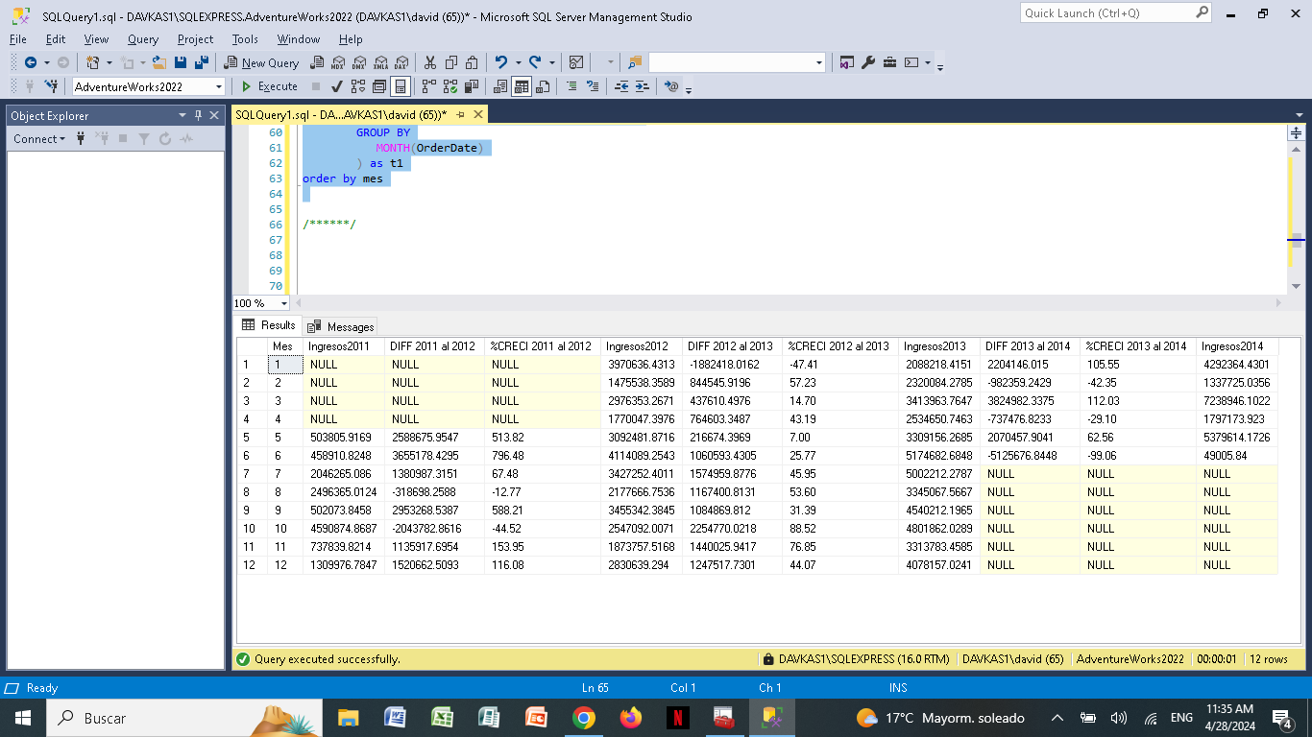

***

**ESTE QUERY NOS DA LA INFORMACIÓN DE EL PORCENTAJE DE CRECIMIENTO QUE TIENE CADA AÑO. DE VENTAS EN LA SALE**

select

t1.Mes,

((t1.Ingresos2012 / t1.Ingresos2011)-1)*100 as '%CRECI 2011 al 2012',

((t1.Ingresos2013 / t1.Ingresos2012)-1)*100 as '%CRECI 2012 al 2013',

((t1.Ingresos2014 / t1.Ingresos2013)-1)*100 as '%CRECI 2013 al 2014'

from

(SELECT

MONTH(soh.OrderDate) AS Mes,

SUM (case when year(soh.OrderDate) = 2011

then (UnitPrice * OrderQty)end) AS Ingresos2011,

SUM (case when year(soh.OrderDate) = 2012

then (UnitPrice * OrderQty)end) AS Ingresos2012,

SUM (case when year(soh.OrderDate) = 2013

then (UnitPrice * OrderQty)end) AS Ingresos2013,

SUM (case when year(soh.OrderDate) = 2014

then (UnitPrice * OrderQty)end) AS Ingresos2014

FROM

Sales.SalesOrderHeader AS soh

JOIN

Sales.SalesOrderDetail AS sod

ON soh.SalesOrderID = sod.SalesOrderID

GROUP BY

MONTH(OrderDate)

) as t1

order by mes

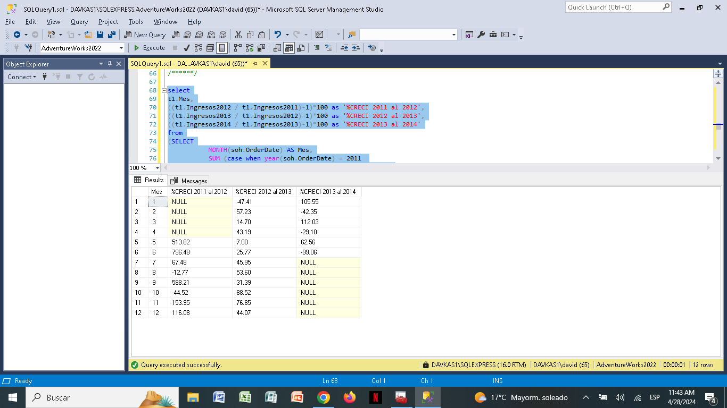

/*********************************************************/

**/*Este Query me devuelve el comportamiento de las ventas por país y por mes*/**

SELECT

t1.Mes,

st.Name AS Region,

cr.Name AS Country,

t1.Ingresos2011,

(t1.Ingresos2012 - t1.Ingresos2011) AS 'DIFF 2011 al 2012',

((t1.Ingresos2012 / t1.Ingresos2011)-1)*100 AS '%CRECI 2011 al 2012',

t1.Ingresos2012,

(t1.Ingresos2013 - t1.Ingresos2012) AS 'DIFF 2012 al 2013',

((t1.Ingresos2013 / t1.Ingresos2012)-1)*100 AS '%CRECI 2012 al 2013',

t1.Ingresos2013,

(t1.Ingresos2014 - t1.Ingresos2013) AS 'DIFF 2013 al 2014',

((t1.Ingresos2014 / t1.Ingresos2013)-1)*100 AS '%CRECI 2013 al 2014',

t1.Ingresos2014

FROM

(SELECT

MONTH(soh.OrderDate) AS Mes,

soh.TerritoryID,

SUM (CASE WHEN YEAR(soh.OrderDate) = 2011 THEN (UnitPrice * OrderQty) END) AS Ingresos2011,

SUM (CASE WHEN YEAR(soh.OrderDate) = 2012 THEN (UnitPrice * OrderQty) END) AS Ingresos2012,

SUM (CASE WHEN YEAR(soh.OrderDate) = 2013 THEN (UnitPrice * OrderQty) END) AS Ingresos2013,

SUM (CASE WHEN YEAR(soh.OrderDate) = 2014 THEN (UnitPrice * OrderQty) END) AS Ingresos2014

FROM

Sales.SalesOrderHeader AS soh

JOIN Sales.SalesOrderDetail AS sod ON soh.SalesOrderID = sod.SalesOrderID

GROUP BY

MONTH(soh.OrderDate), soh.TerritoryID

) AS t1

JOIN

Sales.SalesTerritory AS st ON t1.TerritoryID = st.TerritoryID

JOIN

Person.CountryRegion AS cr ON st.CountryRegionCode = cr.CountryRegionCode

GROUP BY st.Name,cr.Name,t1.Mes,t1.Ingresos2011,t1.Ingresos2012,t1.Ingresos2013,t1.Ingresos2014

ORDER BY st.Name,cr.Name,t1.Mes

—--

**/*Este Query me devuelve el comportamiento exclusivo de un país por cada mes y todos los años*/**

SELECT

t1.Mes,

st.Name AS Region,

cr.Name AS Country,

t1.Ingresos2011,

(t1.Ingresos2012 - t1.Ingresos2011) AS 'DIFF 2011 al 2012',

((t1.Ingresos2012 / t1.Ingresos2011)-1)*100 AS '%CRECI 2011 al 2012',

t1.Ingresos2012,

(t1.Ingresos2013 - t1.Ingresos2012) AS 'DIFF 2012 al 2013',

((t1.Ingresos2013 / t1.Ingresos2012)-1)*100 AS '%CRECI 2012 al 2013',

t1.Ingresos2013,

(t1.Ingresos2014 - t1.Ingresos2013) AS 'DIFF 2013 al 2014',

((t1.Ingresos2014 / t1.Ingresos2013)-1)*100 AS '%CRECI 2013 al 2014',

t1.Ingresos2014

FROM

(SELECT

MONTH(soh.OrderDate) AS Mes,

soh.TerritoryID,

SUM (CASE WHEN YEAR(soh.OrderDate) = 2011

THEN (UnitPrice * OrderQty) END) AS Ingresos2011,

SUM (CASE WHEN YEAR(soh.OrderDate) = 2012

THEN (UnitPrice * OrderQty) END) AS Ingresos2012,

SUM (CASE WHEN YEAR(soh.OrderDate) = 2013

THEN (UnitPrice * OrderQty) END) AS Ingresos2013,

SUM (CASE WHEN YEAR(soh.OrderDate) = 2014

THEN (UnitPrice * OrderQty) END) AS Ingresos2014

FROM

Sales.SalesOrderHeader AS soh

JOIN Sales.SalesOrderDetail AS sod

ON soh.SalesOrderID = sod.SalesOrderID

GROUP BY

MONTH(soh.OrderDate),

soh.TerritoryID

) AS t1

JOIN Sales.SalesTerritory AS st

ON t1.TerritoryID = st.TerritoryID

JOIN Person.CountryRegion AS cr

ON st.CountryRegionCode = cr.CountryRegionCode

WHERE

cr.[Name]like 'United Kingdom'

GROUP BY

st.Name,

cr.Name,

t1.Mes,

t1.Ingresos2011,

t1.Ingresos2012,

t1.Ingresos2013,

t1.Ingresos2014

ORDER BY

st.Name,

cr.Name,

t1.Mes

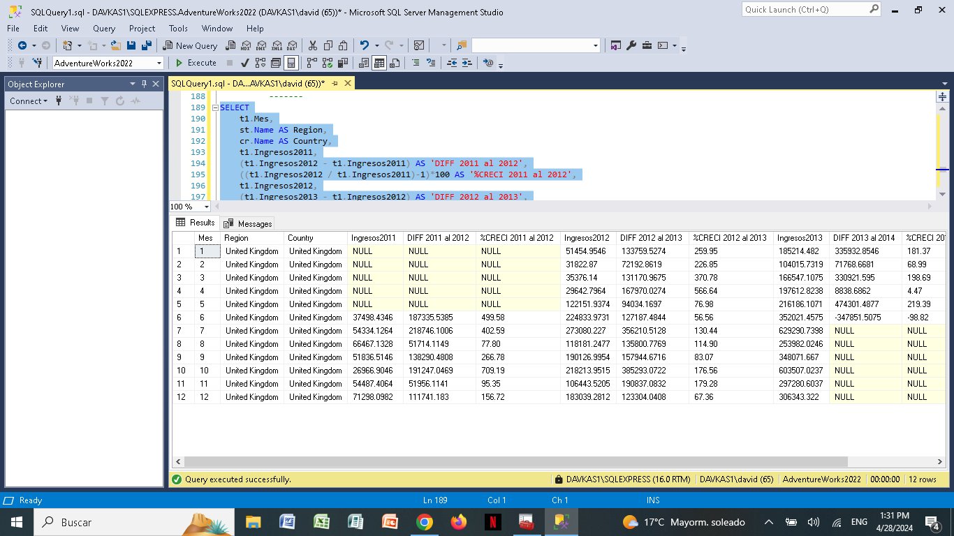

—--

**/*Este Query me devuelve el comportamiento exclusivo de un mes comparando todos los países y regiones de todos los años. Adicional se le incluye el nombre de cada mes*/**

SELECT

DATENAME(MONTH, t1.Mes) AS NombreMes,

st.Name AS Region,

cr.Name AS Country,

t1.Ingresos2011,

(t1.Ingresos2012 - t1.Ingresos2011) AS 'DIFF 2011 al 2012',

((t1.Ingresos2012 / t1.Ingresos2011)-1)*100 AS '%CRECI 2011 al 2012',

t1.Ingresos2012,

(t1.Ingresos2013 - t1.Ingresos2012) AS 'DIFF 2012 al 2013',

((t1.Ingresos2013 / t1.Ingresos2012)-1)*100 AS '%CRECI 2012 al 2013',

t1.Ingresos2013,

(t1.Ingresos2014 - t1.Ingresos2013) AS 'DIFF 2013 al 2014',

((t1.Ingresos2014 / t1.Ingresos2013)-1)*100 AS '%CRECI 2013 al 2014',

t1.Ingresos2014

FROM

(SELECT

MONTH(soh.OrderDate) AS Mes,

soh.TerritoryID,

SUM (CASE WHEN YEAR(soh.OrderDate) = 2011

THEN (UnitPrice * OrderQty) END) AS Ingresos2011,

SUM (CASE WHEN YEAR(soh.OrderDate) = 2012

THEN (UnitPrice * OrderQty) END) AS Ingresos2012,

SUM (CASE WHEN YEAR(soh.OrderDate) = 2013

THEN (UnitPrice * OrderQty) END) AS Ingresos2013,

SUM (CASE WHEN YEAR(soh.OrderDate) = 2014

THEN (UnitPrice * OrderQty) END) AS Ingresos2014

FROM

Sales.SalesOrderHeader AS soh

JOIN Sales.SalesOrderDetail AS sod

ON soh.SalesOrderID = sod.SalesOrderID

GROUP BY

MONTH(soh.OrderDate),

soh.TerritoryID

) AS t1

JOIN

Sales.SalesTerritory AS st

ON t1.TerritoryID = st.TerritoryID

JOIN

Person.CountryRegion AS cr

ON st.CountryRegionCode = cr.CountryRegionCode

WHERE

t1.Mes = 1

GROUP BY

st.Name,

cr.Name,

t1.Mes,

t1.Ingresos2011

,t1.Ingresos2012,

t1.Ingresos2013,

t1.Ingresos2014

ORDER BY

st.Name,

cr.Name,

t1.Mes

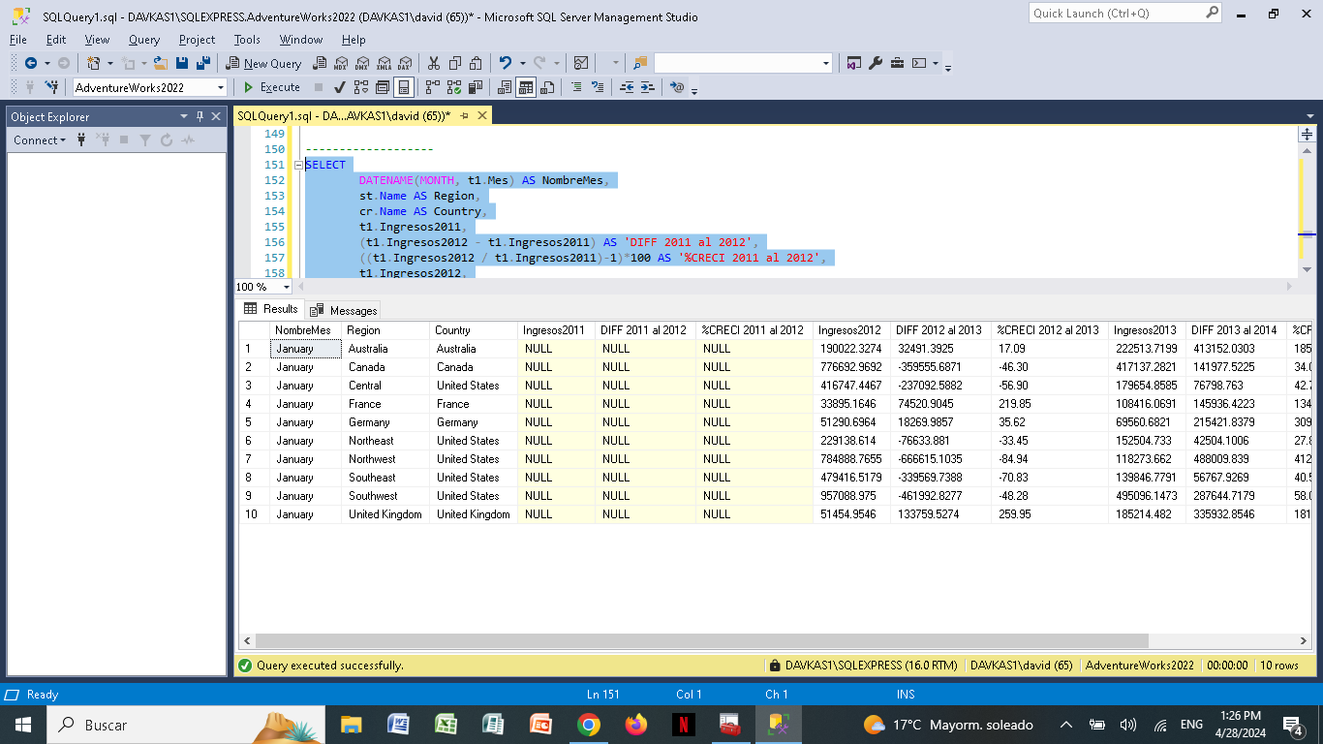

—--

**/*Este Query devuelve el Numero de facturas y el número de productos por cada SalesOrderID, clasificados por continente, territorio y País*/**

SELECT

st.[Group] as 'Continente',

st.[Name] as 'Territorio',

st.CountryRegionCode as 'País',

DATENAME(MONTH, soh.OrderDate) as 'Mes',

soh.SalesOrderID,

COUNT (CASE WHEN YEAR(soh.OrderDate) = 2011

THEN (soh.SalesOrderID) END) as QFacturas,

SUM (CASE WHEN YEAR(soh.OrderDate) = 2011

THEN (sod.OrderQty) END) as QProductos

FROM

Sales.SalesOrderHeader as soh

join sales.SalesOrderDetail as sod

on soh.SalesOrderID = sod.SalesOrderID

join sales.SalesTerritory as st

on st.TerritoryID =soh.TerritoryID

where YEAR(soh.OrderDate) = 2011

Group by

st.[Group],

st.[Name],

st.CountryRegionCode,

soh.OrderDate,

Soh.SalesOrderID

—--------------------------

—--

**/*Este Query devuelve el Numero de facturas y el número de productos por cada SalesOrderID, clasificados por continente, territorio y País, considerando el valor por cada factura*/**

SELECT

st.[Group] as 'Continente',

st.[Name] as 'Territorio',

cr.[Name] as 'NombrePaís',

st.CountryRegionCode as 'CódigoPaís',

DATENAME(MONTH, soh.OrderDate) as 'Mes',

COUNT (CASE WHEN YEAR(soh.OrderDate) = 2011

THEN (soh.SalesOrderID) END) as QFacturas,

SUM( CASE WHEN YEAR(soh.OrderDate) = 2011

THEN sod.OrderQty*sod.UnitPrice END) as 'ValorXFactuta',

SUM (CASE WHEN YEAR(soh.OrderDate) = 2011

THEN (sod.OrderQty) END) as QProductos

FROM

Sales.SalesOrderHeader as soh

join sales.SalesOrderDetail as sod

on soh.SalesOrderID = sod.SalesOrderID

join sales.SalesTerritory as st

on st.TerritoryID =soh.TerritoryID

join Person.CountryRegion as cr

on cr.CountryRegionCode = st.CountryRegionCode

where YEAR(soh.OrderDate) = 2011 and cr.[Name] = 'Australia'

Group by

st.[Group],

st.[Name],

cr.[Name],

st.CountryRegionCode,

soh.OrderDate

Order by soh.OrderDate

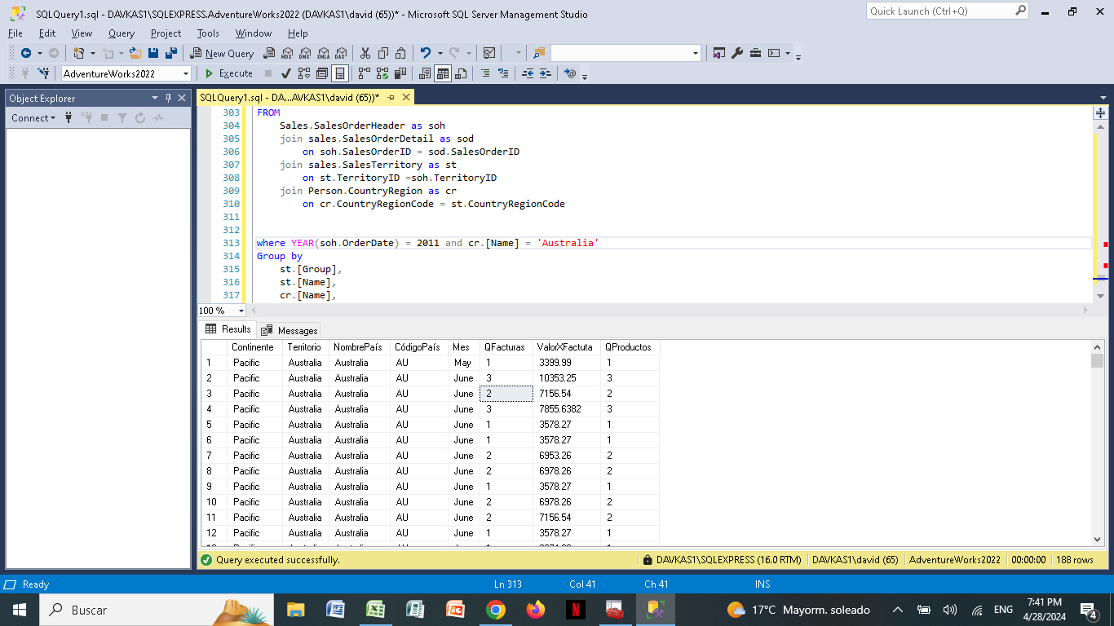

Ventas por territorio con nombre de la persona y la suma de las cantidades.

select soh.OrderDate,

soh.SalesOrderID,

st.[Name] as NombreTerritorio,

sum(sod.OrderQty) as sumacantidad

from Sales.SalesOrderDetail as sod

join Sales.SalesOrderHeader as soh

on sod.SalesOrderID=soh.SalesOrderID

join Production.Product as p

on sod.ProductID=p.ProductID

left join Sales.Customer as c

on soh.CustomerID=c.CustomerID

left join Person.Person as per

on c.CustomerID=per.BusinessEntityID

left join Sales.SalesTerritory as st

on soh.TerritoryID=st.TerritoryID

group by soh.OrderDate,

soh.SalesOrderID,

st.[Name],

CONCAT(per.FirstName, ' ', per.LastName),

p.[Name]

order by

soh.OrderDate,

soh.SalesOrderID,

st.[Name],

CONCAT(per.FirstName, ' ', per.LastName),

p.[Name]

CONCAT(per.FirstName, ' ', per.LastName) as FullName,

p.[Name] as NombreProducto,

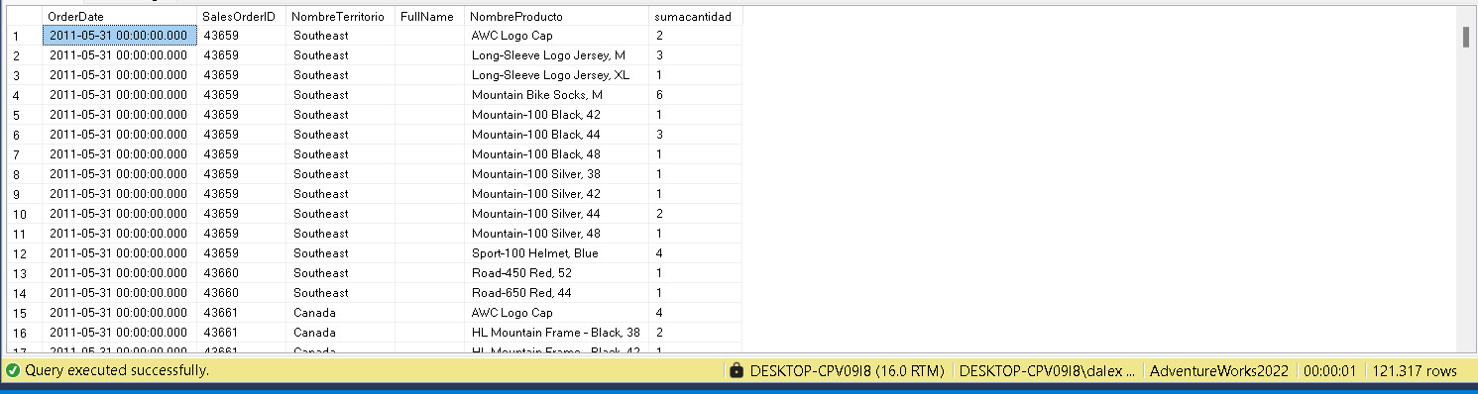

Ventas por territorio

SELECT

st.[Name] AS NombreTerritorio,

SUM(sod.OrderQty) AS sumacantidad,

sum(soh.SubTotal)

FROM Sales.SalesOrderDetail AS sod

JOIN Sales.SalesOrderHeader AS soh

ON sod.SalesOrderID = soh.SalesOrderID

LEFT JOIN Sales.SalesTerritory AS st

ON soh.TerritoryID = st.TerritoryID

GROUP BY

st.[Name];

2013

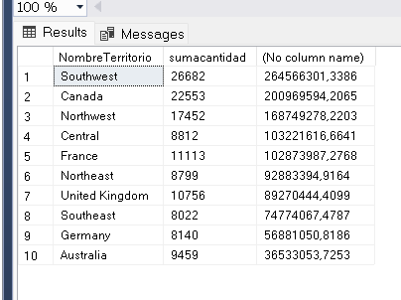

2012

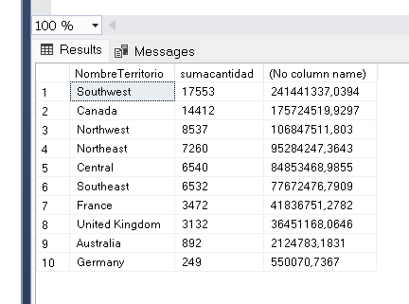

2011

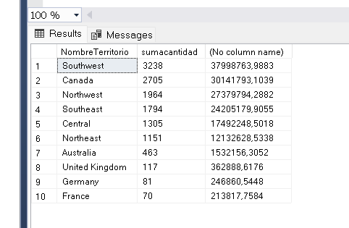

**/*Este query me dice todos los productos que son componentes, porque estan en una orden**

**de trabajo. Por lo tanto son 238 productos que forman parte de ensambles.*/**

select w.ProductID,

p.[Name] as 'ProductName',

c.[Name] as 'CategoryName',

s.[Name] as 'SubCategoryName',

p.ListPrice

from Production.WorkOrder as w

join Production.Product as p

on w.ProductID = p.ProductID

left join Production.ProductSubcategory as s

on s.ProductSubcategoryID = p.ProductSubcategoryID

left join Production.ProductCategory as c

on c.ProductCategoryID = s.ProductCategoryID

group by w.ProductID, p.[Name],c.[Name], s.[Name],p.ListPrice

order by c.[Name]

—--------------------------------------------------------------------------------------

**/*Este Query me indica todos los productos que NO FORMAN PARTE de la tabla WorkOrder,**

**y se reafieren mas a tornilleria, accesorios, repuestos y vestimenta*/**

select p.ProductID,

p.[Name] as 'ProductName',

c.[Name] as 'CategoryName',

s.[Name] as 'SubCategoryName',

p.ListPrice,

p.StandardCost,

(p.ListPrice-p.StandardCost) as Profit,

(p.StandardCost/(p.ListPrice+0.00001))*100 as '%',

SUM(i.Quantity) as 'Cantidad'

from Production.Product as p

left join Production.ProductSubcategory as s

on s.ProductSubcategoryID = p.ProductSubcategoryID

left join Production.ProductCategory as c

on c.ProductCategoryID = s.ProductCategoryID

left join Production.ProductInventory as i

on p.ProductID = i.ProductID

where p.ProductID not in

(select w.ProductID

from Production.WorkOrder as w)

group by

p.ProductID,

p.[Name],

c.[Name],

s.[Name],

p.ListPrice,

p.StandardCost,

(p.ListPrice-p.StandardCost),

(p.StandardCost/(p.ListPrice+0.00001))*100

order by c.[Name]

En el analisis se detecto que varios item que constan en el inventario no cuentan con un costo estandar y esto no permite realizar el analisis adecuado de un valor real del costo de manufactura en los productos estrella que son las bicicletas, teniendo en consideracion que estos productos pueden llegar a categorizarse como componentes y tener un valor fraccional minimo pero que al realizar los calculos respectivos tendra un impacto en la produccion.

**—-----------------------------------------------------------------**

**Checklist**

* Preguntas del pdf: In progress
* **~~Pregunta 1: Contestada~~**
* **~~Pregunta 2: Contestada~~**
* **Pregunta 3:**
* **Sub-Preguntas:**
* **Conclusiones:**
* Dashboard 1: In progress
* Ingresos por meses
* Dashboard 2: In progress
* Análisis de ventas por territorios
* Categoría de productos
* Rentabilidades por territorio
* Ticket promedio
* Ranking mensual y trimestral
* Documentación, interna y externa: In progress
* Interna, SQL(code):
* Externa: Slides:

**—-------------------------------------------------------------------**

**PREGUNTAS**

1. **¿Es el ingreso o la utilidad estacional?**
2. **¿En que años y meses hay una tendencia a la alza o baja según los datos de la compañía?**
3. **¿Selecciona una variable que afecta la utilidad de la compañía, estúdiala y señala las recomendaciones en base a los datos y como esto ayudaría a mejorar la rentabilidad de la empresa?**

**—----**

**Subquestions**

1. **¿Cuál es el promedio de los descuentos de un solo artículo?**
2. **¿Cuál es la cantidad de artículos comprados?**
3. **¿A cuánto asciende el margen (precio de venta menos coste)?**
4. **¿Cuál es el margen promedio (precio de venta menos costo)?**
5. **¿Cuál es el ranking mensual y trimestral del año según el margen (venta menos costo)?**
6. **Examinar los resultados obtenidos y formular al menos 3 conclusiones de negocio.**

**—----------------------------------------------------------------------------------------------------------------------------------**

**PARA SACAR EL PROMEDIO ANUAL DE LA MONEDA POR PAISES**

**SELECT**

**ToCurrencyCode,**

**COUNT(ToCurrencyCode),**

**AVG(AverageRate)**

**FROM Sales.CurrencyRate**

**WHERE CurrencyRateDate LIKE '%2011%'**

**GROUP BY ToCurrencyCode**

**—---------------------------------------------------------------------------------------**

**VENTAS POR MESES DE AUSTRALIA POR VENDEDOR DEL AÑO 2011 AL 2014**

**SELECT**

**MONTH(SOH.OrderDate) AS mes,**

**SOH.SalesPersonID,**

**P.FirstName,**

**P.LastName,**

**ST.CountryRegionCode,**

**E.JobTitle,**

**SUM(CASE WHEN YEAR(SOH.OrderDate)=2011**

**THEN (SOD.UnitPrice*SOD.OrderQty)END) AS Ingresos2011,**

**SUM(CASE WHEN YEAR(SOH.OrderDate)=2011**

**THEN (SOD.OrderQty)END) AS Q_Ordenes_2011,**

**SUM(CASE WHEN YEAR(SOH.OrderDate)=2011**

**THEN (SOD.UnitPrice*SOD.OrderQty/SOD.OrderQty)END) AS VUnit2011,**

**SUM(CASE WHEN YEAR(SOH.OrderDate)=2012**

**THEN (SOD.UnitPrice*SOD.OrderQty)END) AS Ingresos2012,**

**SUM(CASE WHEN YEAR(SOH.OrderDate)=2012**

**THEN (SOD.OrderQty)END) AS Q_Ordenes_2012,**

**SUM(CASE WHEN YEAR(SOH.OrderDate)=2012**

**THEN (SOD.UnitPrice*SOD.OrderQty/SOD.OrderQty)END) AS VUnit2012,**

**SUM(CASE WHEN YEAR(SOH.OrderDate)=2013**

**THEN (SOD.UnitPrice*SOD.OrderQty)END) AS Ingresos2013,**

**SUM(CASE WHEN YEAR(SOH.OrderDate)=2013**

**THEN (SOD.OrderQty)END) AS Q_Ordenes_2013,**

**SUM(CASE WHEN YEAR(SOH.OrderDate)=2012**

**THEN (SOD.UnitPrice*SOD.OrderQty/SOD.OrderQty)END) AS VUnit2013,**

**SUM(CASE WHEN YEAR(SOH.OrderDate)=2014**

**THEN (SOD.UnitPrice*SOD.OrderQty)END) AS Ingresos2014,**

**SUM(CASE WHEN YEAR(SOH.OrderDate)=2014**

**THEN (SOD.OrderQty)END) AS Q_Ordenes_2014,**

**SUM(CASE WHEN YEAR(SOH.OrderDate)=2012**

**THEN (SOD.UnitPrice*SOD.OrderQty/SOD.OrderQty)END) AS VUnit2014**

**FROM**

**Sales.SalesTerritory ST**

**JOIN Sales.SalesOrderHeader AS SOH**

**ON ST.TerritoryID = SOH.TerritoryID**

**JOIN Sales.SalesOrderDetail AS SOD**

**ON SOH.SalesOrderID = SOD.SalesOrderID**

**LEFT JOIN Sales.SalesPerson AS SP**

**ON SOH.SalesPersonID =SP.BusinessEntityID**

**LEFT JOIN Person.Person AS P**

**ON SP.BusinessEntityID = P.BusinessEntityID**

**LEFT JOIN HumanResources.Employee E**

**ON E.BusinessEntityID = P.BusinessEntityID**

**GROUP BY**

**MONTH(SOH.OrderDate),**

**SOH.SalesPersonID,**

**P.FirstName,**

**P.LastName,**

**ST.CountryRegionCode,**

**E.JobTitle**

**ORDER BY mes**

**—---- Consulta para analizar la rotación de mercadería, rentabilidad de productos y la diferencia entre el ingreso del producto con la venta del mismo.**

**SELECT**

**p.ProductID,**

**p.Name AS Producto,**

**SUM(sod.OrderQty * sod.UnitPrice) AS VentasTotales,**

**AVG(pinv.Quantity) AS StockPromedio,**

**SUM(sod.OrderQty * sod.UnitPrice) / AVG(pinv.Quantity+0.00001) AS RotacionMercaderia,**

**SUM(sod.OrderQty * sod.UnitPrice) - (SUM(sod.OrderQty * p.StandardCost)) AS Rentabilidad,**

**AVG(DATEDIFF(DAY, plph.StartDate, soh.OrderDate)) AS DiferenciaDias**

**FROM Production.Product p**

**JOIN Production.ProductInventory as pinv ON p.ProductID = pinv.ProductID**

**JOIN Sales.SalesOrderDetail as sod ON p.ProductID = sod.ProductID**

**JOIN Sales.SalesOrderHeader as soh ON sod.SalesOrderID = soh.SalesOrderID**

**join Production.ProductListPriceHistory as plph on p.ProductID=plph.ProductID**

**GROUP BY**

**p.ProductID,**

**p.Name**

**ORDER BY**

**RotacionMercaderia DESC**

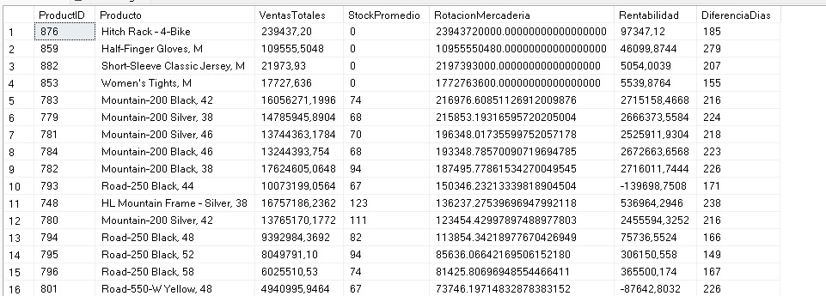

**—---------- Consulta para analizar ventas por territorio, producto más vendido, rentabilidad, precio de venta y diferencia de precio en porcentaje**

**SELECT**

**st.Name AS Territorio,**

**p.Name AS ProductoMasVendido,**

**MAX(pph.ListPrice) AS PrecioEmpresa,**

**MAX(sod.UnitPrice) AS PrecioVenta,**

**(MAX(sod.UnitPrice) - MAX(pph.ListPrice)) / MAX(pph.ListPrice) * 100 AS DiferenciaPrecioPorcentaje**

**FROM Sales.SalesOrderDetail as sod**

**JOIN Sales.SalesOrderHeader as soh ON sod.SalesOrderID = soh.SalesOrderID**

**JOIN Sales.SalesTerritory as st ON soh.TerritoryID = st.TerritoryID**

**JOIN Production.Product as p ON sod.ProductID = p.ProductID**

**JOIN Production.ProductInventory as pinv ON p.ProductID = pinv.ProductID**

**JOIN Production.ProductListPriceHistory as pph ON p.ProductID = pph.ProductID**

**WHERE soh.OrderDate BETWEEN '2011-01-01' AND '2014-12-31'**

**GROUP BY**

**st.Name,**

**p.Name**

**ORDER BY**

**st.Name,**

**MAX(sod.OrderQty) DESC**

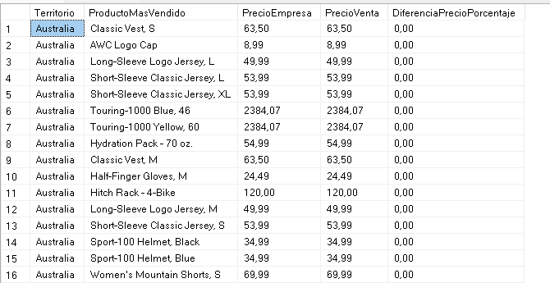

**—---------- Consulta para analizar ventas por COMPRADOR POR TERRITORIO CON EL TTAL DE VENTAS Q DE PRODCTOS COMPRADOS Y POR TIENDAS DE ESTE SE PUEDE DESGLZAR MAS INORMACION POR FECHAS Y POR PAISES Y REGIONES —--**

**SELECT**

**SC.CustomerID,PP.[LastName],PP.[FirstName],**

**COUNT(SSOH.SalesOrderID) Q_SalesOrders,**

**COUNT(PROD.[Name]) AS Q_ProductName,**

**SUM(SSOD.OrderQty) AS SUM_ProductVend,**

**SUM(SSOH.SubTotal) AS SUM_Ventas,**

**SUM(SSOH.SubTotal)/SUM(SSOD.OrderQty) AS Consumo_Prom_Product,**

**SUM(SSOH.SubTotal)/COUNT(SSOH.SalesOrderID) AS Cheque_Prom_Orden,**

**SS.[Name] AS StoreName,**

**SST.[Name],SST.CountryRegionCode**

**FROM**

**Sales.Customer SC**

**LEFT JOIN Person.Person PP**

**ON SC.PersonID = PP.BusinessEntityID**

**LEFT JOIN Sales.SalesOrderHeader SSOH**

**ON SC.CustomerID = SSOH.CustomerID**

**LEFT JOIN Sales.SalesOrderDetail SSOD**

**ON SSOH.SalesOrderID = SSOD.SalesOrderID**

**LEFT JOIN Production.Product PROD**

**ON PROD.ProductID = SSOD.ProductID**

**LEFT JOIN Sales.SalesTerritory SST**

**ON SST.TerritoryID = SC.TerritoryID**

**LEFT JOIN Sales.Store SS**

**ON SC.StoreID = SS.BusinessEntityID**

**/*WHERE SST.CountryRegionCode = 'CA' AND YEAR(SSOH.OrderDate) = 2012*/**

**GROUP BY**

**SC.CustomerID,PP.[LastName],PP.[FirstName],**

**SS.[Name],**

**SST.[Name],SST.CountryRegionCode**

**ORDER BY**

**Q_ProductName DESC, SC.CustomerID,PP.[LastName] ASC, PP.[FirstName] ASC**

**—-------------------------------------------------------------------------------------------------------------------------**

**—*********** ESTE QUERY ESTA MEJORADO AL ANTERIOR YA QUE HAY VALORES DE CALCULO QUE NO COINCIDEN, ASÍ MISMO SE DESCARTO EL NUMERO DE FACTURAS YA QUE AL UNIR CON LA DETAIL CONTABA EL NUMERO DE ITEMS DETALLADOS EN CADA FACTURA Y NO EL NUMERO DE FACTURAS---**

**SELECT**

**SC.CustomerID,**

**CONCAT(PP.[LastName],' ',PP.[FirstName]) AS Cliente,**

**SUM(SSOD.OrderQty) AS Q_ProductVend,**

**SS.[Name] AS StoreName,**

**SST.[Name],SST.CountryRegionCode**

**FROM**

**Sales.Customer SC**

**LEFT JOIN Person.Person PP**

**ON SC.PersonID = PP.BusinessEntityID**

**LEFT JOIN Sales.SalesOrderHeader SSOH**

**ON SC.CustomerID = SSOH.CustomerID**

**LEFT JOIN Sales.SalesOrderDetail SSOD**

**ON SSOH.SalesOrderID = SSOD.SalesOrderID**

**LEFT JOIN Production.Product PROD**

**ON PROD.ProductID = SSOD.ProductID**

**LEFT JOIN Sales.SalesTerritory SST**

**ON SST.TerritoryID = SC.TerritoryID**

**LEFT JOIN Sales.Store SS**

**ON SC.StoreID = SS.BusinessEntityID**

**/*WHERE SST.CountryRegionCode = 'CA' AND YEAR(SSOH.OrderDate) = 2012*/**

**WHERE PP.LastName IS NOT NULL**

**GROUP BY**

**SSOH.SalesOrderID,**

**SC.CustomerID,PP.[LastName],PP.[FirstName],**

**SS.[Name],**

**SST.[Name],SST.CountryRegionCode**

**ORDER BY**

**Q_ProductVend DESC, SC.CustomerID,PP.[LastName] ASC, PP.[FirstName] ASC**